**Assignment 3**

#Laboratory Exercise 5, Home Assignment 3

.data

x: .space 1000 # destination string x, empty

y: .asciiz "Hello World" # source string y

.text

la $a0, x # a0 = x

la $a1, y # a1 = y

strcpy:

add $s0,$zero,$zero #s0 = i=0

L1:

add $t1,$s0,$a1 #t1 = s0 + a1 = i + y[0]

# = address of y[i]

lb $t2,0($t1) #t2 = value at t1 = y[i]

add $t3,$s0,$a0 #t3 = s0 + a0 = i + x[0]

# = address of x[i]

sb $t2,0($t3) #x[i]= t2 = y[i]

beq $t2,$zero,end_of_strcpy #if y[i]==0, exit

nop

addi $s0,$s0,1 #s0=s0 + 1 <-> i=i+1

j L1 #next character

nop

end_of_strcpy:

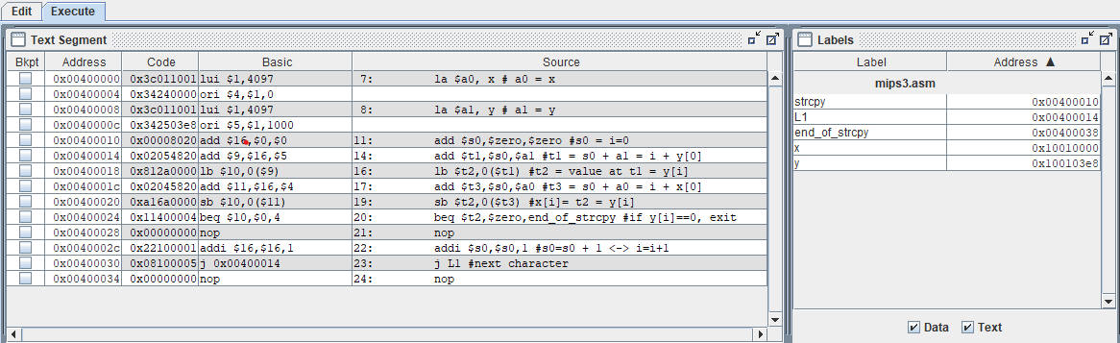

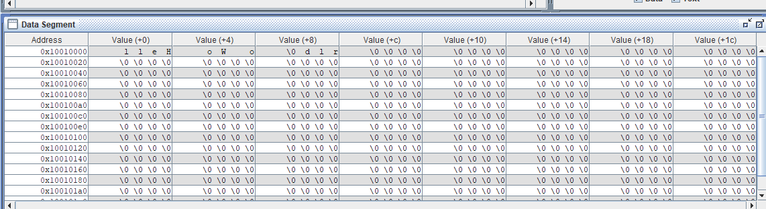

Xâu “ Hello world” đã hiện thị ở bảng data segment